import numpy as np

# Triangular membership function
def trimf(x, a, b, c):
if x <= a or x >= c:
return 0
elif x == b:
return 1
elif x < b:
return (x - a) / (b - a)
else:
return (c - x) / (c - b)

# Inputs
food = 6.5
service = 9.8

# Food membership
food_low = trimf(food, 0, 0, 5)
food_medium = trimf(food, 0, 5, 10)
food_high = trimf(food, 5, 10, 10)

# Service membership
service_low = trimf(service, 0, 0, 5)
service_medium = trimf(service, 0, 5, 10)
service_high = trimf(service, 5, 10, 10)

print("Food Membership:")
print("Low =", food_low)
print("Medium =", food_medium)
print("High =", food_high)

print("\nService Membership:")
print("Low =", service_low)
print("Medium =", service_medium)
print("High =", service_high)

# Rules
rule1 = min(food_low, service_low)
rule2 = min(food_medium, service_medium)
rule3 = min(food_high, service_high)

print("\nRule strengths:")
print("Rule 1 =", rule1)
print("Rule 2 =", rule2)
print("Rule 3 =", rule3)

# Output membership values
tip_low = rule1
tip_medium = rule2
tip_high = rule3

# Centroid using weighted average of output centers
low_center = 4.33
medium_center = 19
high_center = 25

numerator = (tip_low * low_center +
tip_medium * medium_center +
tip_high * high_center)

denominator = tip_low + tip_medium + tip_high

if denominator != 0:
tip = numerator / denominator
else:
tip = 0

print("\nPredicted Tip =", tip)
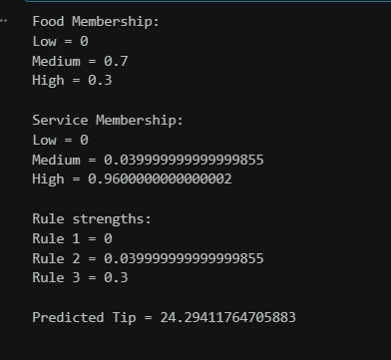
import numpy as np

def trimf(x, a, b, c):
if x <= a or x >= c:
return 0
elif x == b:
return 1
elif x < b:
return (x - a) / (b - a)
else:
return (c - x) / (c - b)

# Inputs
temperature = 28
humidity = 65

# Temperature membership
cold = trimf(temperature, 0, 0, 20)
moderate = trimf(temperature, 15, 25, 30)
hot = trimf(temperature, 25, 40, 40)

# Humidity membership
low = trimf(humidity, 0, 0, 40)
medium = trimf(humidity, 30, 50, 70)
high = trimf(humidity, 60, 100, 100)

print("Temperature:")
print("Cold =", cold)
print("Moderate =", moderate)
print("Hot =", hot)

print("\nHumidity:")
print("Low =", low)
print("Medium =", medium)
print("High =", high)

# Rules
rule1 = min(cold, low)
rule2 = min(cold, high)
rule3 = min(moderate, medium)

# Rule 4 uses OR
rule4 = max(hot, high)

print("\nRule Strengths:")
print("Rule 1 =", rule1)
print("Rule 2 =", rule2)
print("Rule 3 =", rule3)
print("Rule 4 =", rule4)

# Output centers
low_center = 50
medium_center = 50
high_center = 100

numerator = (rule1 * low_center +
max(rule2, rule3) * medium_center +
rule4 * high_center)

denominator = rule1 + max(rule2, rule3) + rule4

if denominator != 0:
fan_speed = numerator / denominator
else:
fan_speed = 0

print("\nPredicted Fan Speed =", fan_speed)
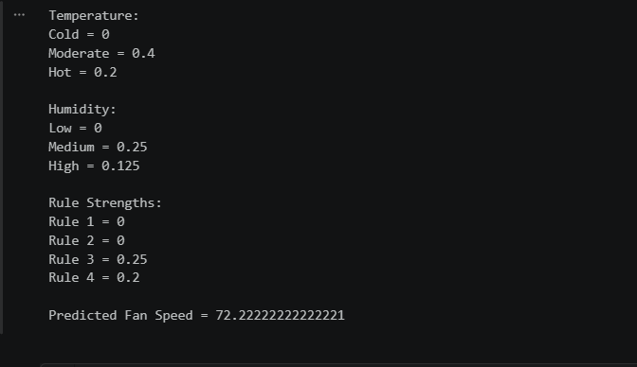import numpy as np

# Objective function
def f(x):
return -x**2 + 2*x + 11

# Initial positions
x = [-1.5, 0, 0.5, 1.25]

# Initial velocities
v = [0, 0, 0, 0]

# Constants
w = 0.8
c1 = 2.05
c2 = 2.05

# r1 and r2 values
r1 = [0.3, 0.2, 0.4, 0.9]
r2 = [0.6, 0.6, 0.1, 0.2]

# Personal best
pbest = x.copy()

# Fitness of pbest
pbest_fitness = []

for i in range(4):
pbest_fitness.append(f(x[i]))

# Global best
gbest_index = np.argmax(pbest_fitness)
gbest = pbest[gbest_index]

print("Initial gbest =", gbest)
print("Initial fitness =", f(gbest))

# 3 iterations
for iteration in range(1, 4):

print("\nITERATION", iteration)

for i in range(4):

# Update velocity
v[i] = (w * v[i]
+ c1 * r1[i] * (pbest[i] - x[i])
+ c2 * r2[i] * (gbest - x[i]))

# Update position
x[i] = x[i] + v[i]

# Apply range
if x[i] < -2:
x[i] = -2

if x[i] > 2:
x[i] = 2

# Calculate fitness
fitness = f(x[i])

# Update pbest
if fitness > pbest_fitness[i]:
pbest[i] = x[i]
pbest_fitness[i] = fitness

# Update gbest
gbest_index = np.argmax(pbest_fitness)
gbest = pbest[gbest_index]

print("Positions =", x)
print("Fitness =", [f(value) for value in x])
print("Pbest =", pbest)
print("Pbest fitness =", pbest_fitness)
print("Gbest =", gbest)
print("Gbest fitness =", f(gbest))

print("\nBEST PARTICLE =", gbest_index + 1)
print("BEST POSITION =", gbest)
print("BEST FITNESS =", f(gbest))
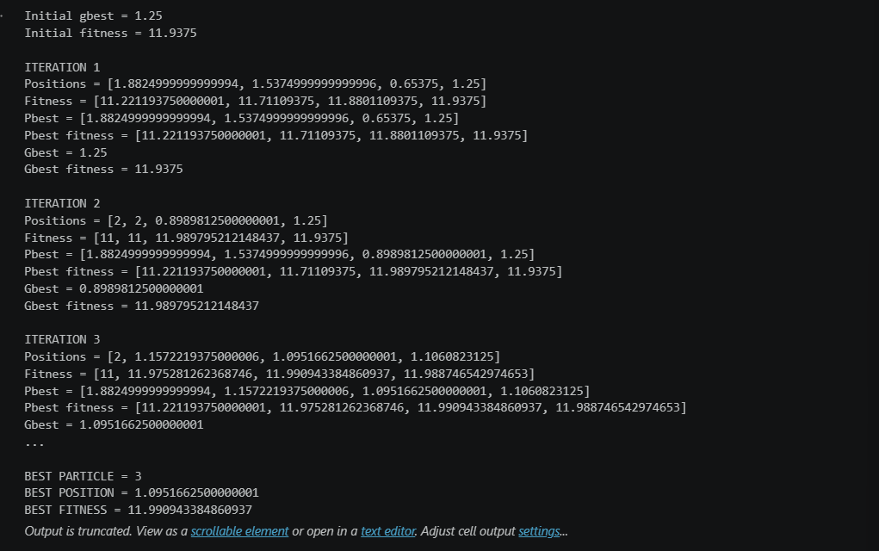
import numpy as np

def f(x):
return (x - 3) ** 2

# Initial positions
x = [0, 4, 5]

# Initial velocities
v = [0, 0, 0]

# Constants
w = 0.5
c1 = 1
c2 = 1
r1 = 0.5
r2 = 0.5

# Personal best
pbest = x.copy()

# Fitness
pbest_fitness = []

for i in range(3):
pbest_fitness.append(f(x[i]))

# Global best
gbest_index = np.argmin(pbest_fitness)
gbest = pbest[gbest_index]

iteration = 0

while True:

iteration = iteration + 1

print("\nITERATION", iteration)

for i in range(3):

# Velocity update
v[i] = (w * v[i]
+ c1 * r1 * (pbest[i] - x[i])
+ c2 * r2 * (gbest - x[i]))

# Position update
x[i] = x[i] + v[i]

# Apply range
if x[i] < -5:
x[i] = -5

if x[i] > 5:
x[i] = 5

# Fitness
fitness = f(x[i])

# Update pbest
if fitness < pbest_fitness[i]:
pbest[i] = x[i]
pbest_fitness[i] = fitness

# Update gbest
gbest_index = np.argmin(pbest_fitness)
gbest = pbest[gbest_index]

print("Position =", x)
print("Fitness =", [f(value) for value in x])
print("Pbest =", pbest)
print("Pbest fitness =", pbest_fitness)
print("Gbest =", gbest)
print("Gbest fitness =", f(gbest))

# Position tolerance
position_difference = max(abs(x[i] - pbest[i]) for i in range(3))

if position_difference < 0.01:
break

print("\nFINAL GBEST =", gbest)
print("FINAL FITNESS =", f(gbest))
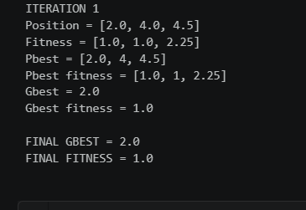
import numpy as np

def f(x):
return x ** 2

# Initial positions
x = [4, -3, 2]

# Initial velocities
v = [1, -1, 0.5]

# Constants
w = 0.5
c1 = 1
c2 = 1
r1 = 0.5
r2 = 0.5

# Personal best
pbest = x.copy()

# Fitness
pbest_fitness = []

for i in range(3):
pbest_fitness.append(f(x[i]))

# Global best
gbest_index = np.argmin(pbest_fitness)
gbest = pbest[gbest_index]

iteration = 0

while True:

iteration += 1

print("\nITERATION", iteration)

for i in range(3):

# Velocity
v[i] = (w * v[i]
+ c1 * r1 * (pbest[i] - x[i])
+ c2 * r2 * (gbest - x[i]))

# Position
x[i] = x[i] + v[i]

# Range
if x[i] < -10:
x[i] = -10

if x[i] > 10:
x[i] = 10

# Fitness
fitness = f(x[i])

# Update pbest
if fitness < pbest_fitness[i]:
pbest[i] = x[i]
pbest_fitness[i] = fitness

# Update gbest
gbest_index = np.argmin(pbest_fitness)
gbest = pbest[gbest_index]

print("Position =", x)
print("Velocity =", v)
print("Fitness =", [f(value) for value in x])
print("Pbest =", pbest)
print("Pbest fitness =", pbest_fitness)
print("Gbest =", gbest)
print("Gbest fitness =", f(gbest))

# Stop condition
if f(gbest) < 0.05:
break
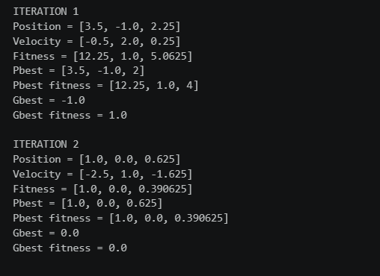
import numpy as np

def f(x):
return x ** 2

# Initial positions
x = [6, 4, 8]

# Initial velocities
v = [0, 0, 0]

# Constants
w = 0.5
c1 = 1
c2 = 1
r1 = 0.5
r2 = 0.5

# Personal best
pbest = x.copy()

# Personal best fitness
pbest_fitness = []

for i in range(3):
pbest_fitness.append(f(x[i]))

# Global best
gbest_index = np.argmin(pbest_fitness)
gbest = pbest[gbest_index]

iteration = 0

while True:

iteration += 1

print("\nITERATION", iteration)

for i in range(3):

# Update velocity
v[i] = (w * v[i]
+ c1 * r1 * (pbest[i] - x[i])
+ c2 * r2 * (gbest - x[i]))

# Update position
x[i] = x[i] + v[i]

# Range
if x[i] < -10:
x[i] = -10

if x[i] > 10:
x[i] = 10

# Calculate fitness
fitness = f(x[i])

# Update pbest
if fitness < pbest_fitness[i]:
pbest[i] = x[i]
pbest_fitness[i] = fitness

# Update gbest
gbest_index = np.argmin(pbest_fitness)
gbest = pbest[gbest_index]

print("Position =", x)
print("Velocity =", v)
print("Fitness =", [f(value) for value in x])
print("Pbest =", pbest)
print("Pbest fitness =", pbest_fitness)
print("Gbest =", gbest)
print("Gbest fitness =", f(gbest))

# Stop when global fitness <= 10
if f(gbest) <= 10:
break
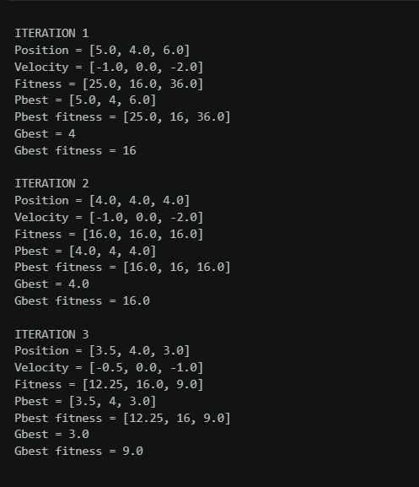
# Fan speed
x = [0, 1, 2, 3, 4, 5, 6, 7, 8, 9, 10]

# Membership values
mu = [0, 0.2, 0.5, 0.7, 0.8, 0.6, 0.4, 0.2, 0, 0, 0]

# Calculate numerator
numerator = 0

for i in range(len(x)):
numerator = numerator + x[i] * mu[i]

# Calculate denominator
denominator = 0

for i in range(len(mu)):
denominator = denominator + mu[i]

# Centroid
centroid = numerator / denominator

print("Numerator =", numerator)
print("Denominator =", denominator)
print("Centroid =", centroid)
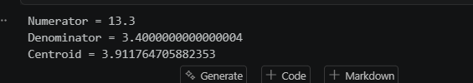
# Membership values
mu = [0, 0.2, 0.5, 0.7, 0.8, 0.6, 0.4, 0.2, 0, 0, 0]

print("Original Membership:")
print(mu)

# Very small = mu^2
very_small = []

for value in mu:
very_small.append(value ** 2)

# Fairly small = sqrt(mu)
fairly_small = []

for value in mu:
fairly_small.append(value ** 0.5)

# Very very large = mu^4
very_very_large = []

for value in mu:
very_very_large.append(value ** 4)

# Not fairly large
# Fairly = sqrt(mu)
# Not = 1 - membership
not_fairly_large = []

for value in mu:
fairly = value ** 0.5
not_fairly = 1 - fairly
not_fairly_large.append(not_fairly)

# Very very small = mu^4
very_very_small = []

for value in mu:
very_very_small.append(value ** 4)

print("\nVery Small:")
print(very_small)

print("\nFairly Small:")
print(fairly_small)

print("\nVery Very Large:")
print(very_very_large)

print("\nNot Fairly Large:")
print(not_fairly_large)

print("\nVery Very Small:")
print(very_very_small)
